PT Activity 2.6.1: Packet Tracer Skills Integration Challenge (Solution)

Topology Diagram

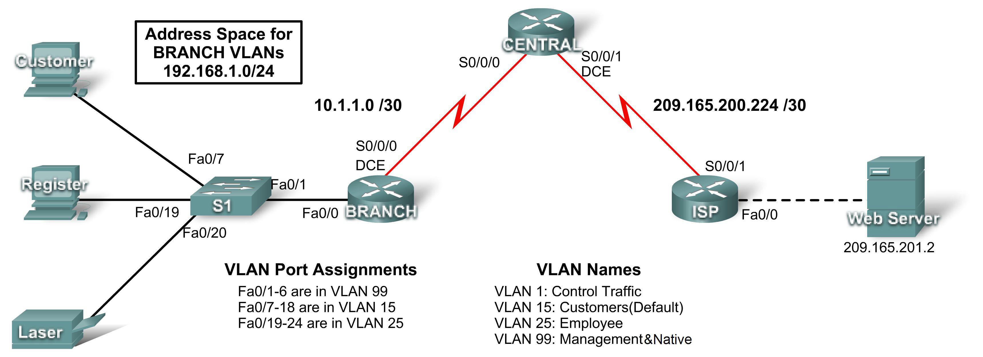

Addressing Table
Device | Interface | IP Address | Subnet Mask | Default Gateway
CENTRAL | S0/0/0 | 10.1.1.2 | 255.255.255.252 | N/A
CENTRAL | S0/0/1 | 209.165.200.226 | 255.255.255.252 | N/A
ISP | S0/0/1 | 209.165.200.225 | 255.255.255.252 | N/A
ISP | Fa0/0 | 209.165.201.1 | 255.255.255.252 | N/A
BRANCH | Fa0/0.1 | 192.168.1.193 | 255.255.255.224 | N/A
BRANCH | Fa0/0.15 | 192.168.1.1 | 255.255.255.128 | N/A
BRANCH | Fa0/0.25 | 192.168.1.129 | 255.255.255.192 | N/A
BRANCH | Fa0/0.99 | 192.168.1.225 | 255.255.255.224 | N/A
BRANCH | S0/0/0 | 10.1.1.1 | 255.255.255.252 | N/A
S1 | VLAN99 | 192.168.1.226 | 255.255.255.224 | 192.168.1.225
Customer | NIC | 192.168.1.2 | 225.255.255.128 | 192.168.1.1
Register | NIC | 192.168.1.130 | 225.255.255.192 | 192.168.1.129
Laser | NIC | 192.168.1.190 | 225.255.255.192 | 192.168.1.129
Web Server | NIC | 209.165.201.2 | 255.255.255.252 | 209.165.201.1

Learning Objectives
- Configure static and default routing.
- Add and connect a router.
- Design and document an addressing scheme.
- Add and connect devices in an address space.
- Configure basic device settings.
- Configure PPP encapsulation with CHAP.
- Configure OSPF routing.
- Configure VLANs.
- Verify connectivity.
Task 1: Configure Static and Default Routing
Step 1. Configure static routing from ISP to CENTRAL.
Use the passwords cisco and class to access EXEC modes of the CLI for routers. Configure two static routes on ISP using the exit interface argument to the following networks:
- 10.1.1.0/30
- 192.168.1.0/24
Step 2. Configure default routing from CENTRAL to ISP.
Configure a default route on CENTRAL using the exit interface argument to send all default traffic to ISP.
Step 3. Test connectivity to Web Server.
CENTRAL should be able to successfully ping Web Server at 209.165.201.2
Step 4. Check results.
Your completion percentage should be 4%. If not, click Check Results to see which required components are not yet completed.
Task 2: Add and Connect a Router
Step 1. Add the BRANCH router.
Click Custom Made Devices and add an 1841 router to the topology. Use the Config tab to change the Display Name to BRANCH. Display names are case-sensitive. Do not change the hostname yet.
Step 2. Connect BRANCH to CENTRAL.
Choose the correct cable and connect BRANCH to CENTRAL according to the interfaces shown in the topology.
Step 3. Check results.
Your completion percentage should be 9%. If not, click Check Results to see which required components are not yet completed. If you changed the hostname in Step 2, then your percentage will be higher.
Task 3: Design and Document an Addressing Scheme
Step 1. Design an addressing scheme.
Using the topology and the following requirements, design an addressing scheme:
- Addressing is provided for all WAN links.
- For the VLANs attached to BRANCH, use the address space 192.168.1.0/24. Starting with the largest host requirement, assign subnets in the following order for all VLANs.
  - VLAN 15 needs space for 100 hosts ____________________ 192.168.1.0/25
  - VLAN 25 needs space for 50 hosts ____________________ 192.168.1.128/26
  - VLAN 1 needs space for 20 hosts ____________________ 192.168.1.192/27
  - VLAN 99 needs space for 20 hosts ____________________ 192.168.1.224/27
Step 2. Document the addressing scheme.
- Complete the addressing table using the following guidelines. You will add the remaining devices in the next task.
  - Assign the first address in each VLAN to the corresponding BRANCH subinterface. The subinterface numbers match the VLAN numbers.
  - Assign the second address in VLAN 99 to S1.
  - Assign the second address in VLAN 15 to the Customer PC.
  - Assign the second address in VLAN 25 to the Register PC.
  - Assign the last address in VLAN 25 to the laser printer.
- Be sure you record the appropriate subnet mask and default gateway for each address.
Task 4: Add and Connect the Devices in the Address Space
Step 1. Add S1, Customer PC, Register PC, and the laser printer in the 192.168.1.0/24 address space.
- S1 is a 2960 switch. Add it to the topology and change the Display Name to S1. Display names are case-sensitive. Do not change the hostname yet.
- The PCs and printer are listed under End Devices. Add two PCs and a printer. Change the display names of the PCs and printer according to the topology.
Step 2. Connect S1 to BRANCH.
Choose the correct cable and connect S1 to BRANCH according to the interfaces shown in the topology.
Step 3. Connect Customer PC, Register PC, and the laser printer to S1.
Choose the correct cable and connect the PCs and printer to S1 according to the interfaces shown in the topology.
Step 4. Check results.
Your completion percentage should be 22%. If not, click Check Results to see which required components are not yet completed. If you changed the hostname of S1 in Step 1, then your percentage will be higher.
Task 5: Configure Basic Device Settings
Step 1. Configure BRANCH and S1.
Using your documentation, set the basic configuration for BRANCH and S1, including addressing. Use cisco as the line password and class as the secret password. Use 64000 as the clock rate. Graded portions of the basic configuration include:
- Hostnames, which are case-sensitive.
- Interface addressing and activation. Set clocking to 64000 bps.
- For interface Fa0/0.99, configure VLAN 99 as the native VLAN.
- Interface VLAN 99 creation and addressing on S1. Activating VLAN 99 is done after the trunk is configured later in the activity.
Step 2. Configure remaining devices.
Using your documentation, configure the PCs and printer with the correct addressing.
Step 3. Test connectivity between BRANCH and CENTRAL.
CENTRAL should now be able to successfully ping BRANCH. S1 cannot ping until trunking is configured.
Step 4. Check results.
Your completion percentage should be 63%. If not, click Check Results to see which required components are not yet completed.
Task 6: Configure PPP Encapsulation with CHAP Authentication
Step 1. Configure CENTRAL to use PPP with CHAP for the link to BRANCH.
The password for CHAP authentication is cisco123. The link goes down.
Step 2. Configure BRANCH to use PPP with CHAP for the link to CENTRAL.
The password for CHAP authentication is cisco123. The link comes back up.
Step 3. Test Connectivity between BRANCH and CENTRAL.
It may take Packet Tracer a little longer than real equipment to bring the interfaces back up. Once the interfaces come up, CENTRAL should be able to successfully ping BRANCH.
Step 4. Check results.
Your completion percentage should be 71%. If not, click Check Results to see which required components are not yet completed.
Task 7: Configure OSPF Routing
Step 1. Configure OSPF on CENTRAL.
- Configure OSPF using the process ID 1.
- Add only the network shared with BRANCH.
- Propagate the default route to OSPF neighbors.
- Disable OSPF updates to ISP.
Step 2. Configure OSPF on BRANCH.
- Configure OSPF using the process ID 1.
- Add all active networks that BRANCH routes.
- Disable OSPF updates to the VLANs.
Step 3. Test connectivity to Web Server.
BRANCH should now be able to successfully ping Web Server at 209.165.201.2.
Step 4. Check results.
Your completion percentage should be 86%. If not, click Check Results to see which required components are not yet completed.
Task 8: Configure VLANs
Step 1. Add VLANs to S1.
VLAN names are case-sensitive. Add and name the four VLANs using the following specifications:
- VLAN 15; name is Customers(Default)
- VLAN 25; name is Employee
- VLAN 99; name is Management&Native
Step 2. Assign ports to the appropriate VLANs and activate interface VLAN 99.
- Using the VLAN Port Assignments shown in the topology diagram, configure the access ports attached to the end devices and assign each to the correct VLAN.
- Enable trunking on the Fa0/1 port and configure it to use VLAN 99 as the native VLAN.
- Activate interface VLAN 99, if necessary. It should already be up.
Step 3. Check results.
Your completion percentage should be 100%. If not, click Check Results to see which required components are not yet completed.
Task 9: Verify connectivity
Step 1. Verify that Customer PC, Register PC, and the laser printer can ping each other.
Step 2. Verify that Customer PC, Register PC, and laser printer can ping Web Server.

